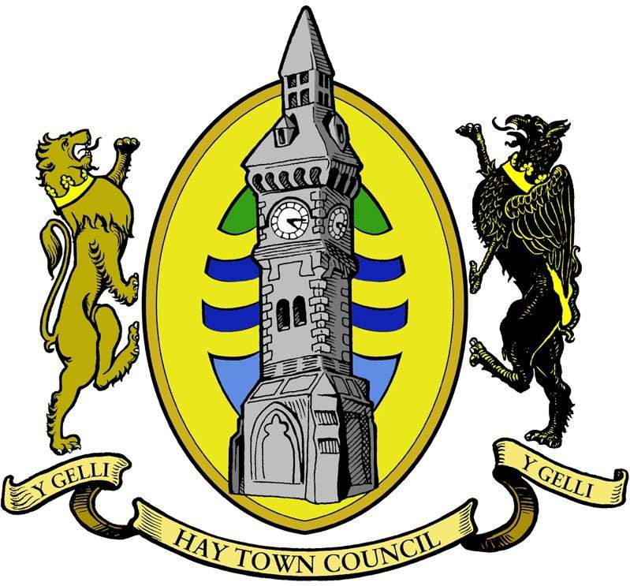
-
# #####
Hay Town Council
Hay Town Council Council Offices Recreation Facilities Brecon Road
Hay-on-Wye HR3 5DY
01497 808019
townclerk@haytowncouncil.gov.uk www.haytowncouncil.gov.uk

HAY TOWN COUNCIL, Minutes of the Ordinary Meeting
Held on Monday 12 October 2026 at 6.00 pm Council Office, Brecon Road, Hay-on-Wye, HR3 5DY

Present: Cllr F Howard (Chair), Cllr J Morgan, Cllr K Elleson, Cllr A Bielski, Cllr W Bielska, Cllr G Ratcliffe, Cllr S Eugene and Cllr H Horwood.
Cllr G Williams joined the meeting during Item 16.
In attendance:
C Bunton (Clerk/RFO) and one member of the public.

1. Apologies for Absence
No apologies for absence were recorded.

2. Declarations of Interest and Code of Conduct
No declarations of interest were made.

3. Questions from Members of the Public
No questions were raised.

4. Police Report – PC 899 Dan Mikes-Stephens
PC Dan Mikes-Stephens was not in attendance. No report was received.

5. Approval of Previous Minutes
The minutes of the Town Council meetings held on 14 September and 17 September 2026, having been previously circulated, were considered.
RESOLVED: Unanimously agreed that the minutes previously circulated of the Town Council meeting held on the 14 September and 17 September 2026, be accepted as a true and accurate record.

6. 50 Years of Hay Independence
Members received an update regarding arrangements to commemorate 50 years of Hay's independence.
It was reported that Ritchie and Lyndy were progressing plans for the celebrations, which would incorporate a circus theme.
A full progress report was requested for the next meeting.

7. Hay Place Plan
Members discussed progress on the Hay Place Plan and the Council's current workload.
It was noted that the Plan was required to be completed by May 2027.
RESOLVED: That further work on the Place Plan be deferred until January 2027 to allow the Council to prioritise other ongoing projects.
Proposed: Cllr F Howard, Seconded: Cllr G Ratcliffe, Unanimously agreed.

8. Council Surveys
Members received an update on the Council's ongoing surveys.
It was reported that all surveys had been completed except those relating to borders and assets.
The relevant working group would arrange a meeting with Cllr J Morgan to progress the outstanding work.

9. Friends of Hay Town Council
Members received an update on the establishment of the Friends of Hay Town Council volunteer initiative.
It was reported that there had been considerable public interest in joining the scheme.
It was agreed that progress reports would be presented to Full Council quarterly.

10. Community Groups QR Code Information Board
Cllr A Bielski reported on progress with the proposed community groups information board.
The board would provide QR codes enabling residents and visitors to access information about local community groups and activities.
Members discussed the potential inclusion of volunteering opportunities, subject to the available space.
It was proposed that the board be produced in A3 format, with information reviewed in June 2027 and annually thereafter. The possibility of a digital version was also discussed as a longer-term option.
It was noted that space may be available on the Cusop village noticeboard.
Cllr S Eugene offered assistance with the project.
Action: Cllr A Bielski to progress the project and arrange a Facebook post inviting local community groups to express an interest in being included.

11. InPost Lockers
Members received an update on the installation of the InPost lockers.
It was reported that the foundations had been completed and that an electrical supply box was being installed.
The Council would publicise the facility once operational.

12. Public Open Meeting
Members discussed arrangements for the Council's next public open meeting.
It was noted that holding the meeting in November would be difficult due to existing commitments.
RESOLVED: That the public open meeting be scheduled for April 2027, prior to the ordinary meeting of the Town Council. Proposed: Cllr F Howard, Seconded: Cllr J Morgan, Unanimously agreed.

13. Views from Seating – Bailey Walk and The Warren
Members considered a complaint regarding vegetation obstructing views of the River Wye from seating along the Bailey Walk. It was reported that Hay Community Woodland Group had offered to undertake vegetation clearance through a volunteer working party. The proposed works would involve the removal of scrub and overhanging branches. The scope of the proposed works and any necessary permissions would be confirmed before work commenced.

14. Powys Teaching Health Board – Community Hospital Beds
Members discussed the proposed changes to community hospital bed provision and the ongoing public consultation.
Concerns were raised regarding the potential removal of beds and the clarity of the proposals.
It was noted that the Council had been invited to share information about the consultation and had a three-month period in which to respond. Members considered the importance of providing local residents with an opportunity to obtain information and express their views.
RESOLVED: That the Council request that the Health Board hold a public information and consultation session in Hay-on-Wye. The Council would offer the use of the Pavilion as a potential venue. Proposed: Cllr G Ratcliffe Seconded: Cllr F Howard Unanimously agreed.
Actions:
- Clerk to contact the Health Board requesting a public drop-in session.
- Cllr S Eugene to lead a working group to consider the proposals and coordinate the Council's response.

15. Council Communications – Wye Local
Members discussed the Council's communications and the possibility of publishing regular updates in Wye Local.
It was noted that the Council did not currently have a regular presence in the publication.
Members considered the potential benefits of quarterly articles and the associated financial implications.
It was agreed that provision for quarterly communications should be considered by the Finance Committee as part of the 2027/28 precept discussions. Members noted that articles had previously been prepared by the Council's Communications Subcommittee.

16. Parish Hall
Members received an update on discussions concerning the future of the Parish Hall.
It was reported that meetings had taken place and that further discussions with the Church were planned.
A public meeting was also anticipated. Members discussed the possibility of appointing a Town Council representative to the relevant committee to provide support. No appointment was made at this meeting.

Cllr G Williams joined the meeting.

17. Councillor Project Reports
a) Play Area Working Group
Members received an update following a recent meeting of the Play Area Working Group.
It was reported that discrepancies had been identified in the Land Registry records relating to Council land.
The next stage of the project would involve investigating and addressing these discrepancies.
Members discussed the working group progressing this work independently until January 2027, without requiring additional administrative support from the Clerk.

b) Town Enhancements
Members received an update on ongoing town enhancement projects.
It was reported that a new bench had been installed and that work was progressing on associated signage and new town banners. Payment from Powys County Council remained outstanding.
Regarding the Council's heritage audio project, it was proposed that the audio recordings be reduced to approximately 45 seconds each, with full written transcripts made available on the Council's website. This was agreed.

c) Remembrance Sunday
Members received an update on arrangements for Remembrance Sunday. It was reported that preparations were progressing and invitations had been issued. Members were advised that the Police would no longer be available to undertake road closures. The possibility of using registered Council volunteers to assist was discussed.
The Pavilion would be opened at 1.30 pm.
Arrangements were being made for the band to perform the Lament, and Cllr G Ratcliffe would organise the public address system.
The availability of ceremonial robes remained subject to their completion.
Action: Enquiries to be made with Friends of HTC regarding their availability to assist with the event, subject to appropriate arrangements and permissions.

d) Town Crier
Cllrs F Howard and J Morgan reported that they had met with a prospective Town Crier.
It was confirmed that a seamstress was willing to undertake alterations to the ceremonial robes.
Members were advised that Haydn retained some of the former Town Crier's uniform.
Action: Cllr F Howard to contact Haydn regarding the availability of the remaining uniform items.

e) Oxford Road Public Toilets
Members received a progress report on the refurbishment of the Oxford Road public toilets.
Works commenced on 1 September 2026 and were reported to be progressing satisfactorily and within the allocated budget. Representatives of the Pride in Place funding programme had visited the site and viewed the improvements.
It was anticipated that the main male and female facilities would be completed by the end of next week, with the remaining facilities requiring approximately a further two weeks.
An outstanding query remained with Powys County Council concerning responsibility for the drainage infrastructure.
It was also reported that the coin-operated payment mechanism in the unisex toilet was defective.
Action: Clerk to continue correspondence with Powys County Council regarding drainage ownership, copying Cllr G Ratcliffe into the correspondence.

18. Committee and Working Group Reports
a) Finance Committee
i. Precept 2027/28
Members were reminded that all committees and working groups must submit their budget requests in advance of the next Full Council meeting.

ii. Audit Wales Report 2025/26
The Council received and considered the external audit report issued by the Auditor General for Wales for the financial year 2025/26. Members noted the qualified audit opinion and the matters raised within the report.
The Council acknowledged the need to consider any recommendations and appropriate actions arising from the audit findings.

iii. Council Website
Members discussed the Council's website and the need to review its suitability and future requirements.
It was proposed that the Finance Committee investigate the available options and report its recommendations to Full Council. Proposed: Cllr G Ratcliffe, Seconded: Cllr K Elleson, Unanimously agreed.

b) Estates Committee
i. Storage Container
Members were advised that the new storage container had been installed by Mark Eggerton. The Council expressed its thanks to Ade Bunton for his assistance with the installation.

ii. Public Benches
New benches have been ordered for the Old Railway Line. Members noted the grant support received from Llais Y Goedwig and the involvement of Hay Community Woodland Group in the provision of a 360-degree bench.
Two additional benches would replace the deteriorated seating at the rear of Warren Close.

iii. Gipsy Castle Play Area
Members were advised that complaints had been received regarding the entrance gate and overgrown brambles. OTM had been commissioned to undertake repairs and remove overgrown brambles and ivy. Works would also include cutting back the hedge adjoining the allotments. This will include fixing the gate.

iv. Timber Near Watercourse
Welsh Water had been contacted regarding timber left on the ground following works.
Concern had been expressed that the timber could be carried downstream during periods of flooding and cause an obstruction. Welsh Water have confirmed the timber will be removed before flooding season.

v. Duty of Care Tree Survey
The annual Duty of Care Tree Survey was confirmed for 20 October 2026.

vi. Cricket Club
Members were advised that the Cricket Club intended to commence groundwork for its storage container on Thursday 15 October 2026.

vii. Bollards
The Clerk has been reminding relevant parties that the bollards must remain in the raised position.

d) Premises Committee
i. Clock Tower Toilets
No specific matters were recorded.
ii. Oxford Road Toilets
Members discussed a request for the public toilets to remain open between 4.00 pm and 8.00 pm on 13 December 2026 to accommodate visitors attending the Tractor Run.

iii. Pavilion
Members received an update on work to improve the Pavilion. It was reported that unwanted items had been removed, with the exception of the washing machine. Further improvements under consideration included carpet cleaning, painting and replacement of equipment or furnishings. Members discussed the need to obtain approximately six to eight large tables and two smaller tables.
Action: Cllr K Elleson to arrange a meeting to consider the outstanding works and requirements.

e) Light Up Hay
i. Christmas Lights Switch-On
Members received an update on arrangements for the Christmas lights switch-on event on 27 November 2026.
Hay Festival had requested that the lights be switched on at 6.15 pm. Charity stalls were being booked for the Butter Market. Members discussed event safety arrangements, including the need to ensure that exits were appropriately managed. It was confirmed that arrangements for fire and steam attractions were progressing. Volunteers would be required to assist with the switch-on. Walkie-talkies would be made available by Tom. Cllr J Morgan would assist with closing arrangements. The Council expressed its appreciation to Hay Festival for its support.

ii. Christmas Calendars
Cllr S Eugene reported that the Christmas calendars had been prepared with assistance from her husband, Justin.
The Council expressed its thanks to those involved. Members discussed the proposed selling price and VAT implications. RESOLVED: That the calendars be sold at £10 each. Proposed: Cllr K Elleson, Seconded: Cllr J Morgan
Unanimously agreed.
Action: Cllr G Williams to investigate the VAT position.
Any outstanding comments on the calendar were to be submitted by the end of the week.

iii. Christmas Lighting – Electrical Testing
Members received an update on the testing of the Council's Christmas lighting equipment. Testing was approximately two-thirds complete. It was reported that approximately 35 metres of lighting had been identified as defective. Issues included incompatible connectors and polarity-sensitive connections. Working-at-height arrangements were also being reviewed.

19. Council Policies and Governance Documents
Members considered the adoption and review of Council policies and governance documents.
The Finance Committee recommended that Full Council adopt the revised Financial Regulations 2026 and approve the Schedule of Continuing Contracts and Obligations.
i. Schedule of Continuing Contracts and Obligations
RESOLVED: That the Schedule of Continuing Contracts and Obligations be approved as presented. Proposed: Cllr W Bielska Seconded: Cllr K Elleson, Unanimously agreed.
ii. Standing Orders
Members considered the revised Standing Orders.
RESOLVED: That Hay Town Council adopt the revised Standing Orders as presented. Proposed: Cllr A Bielski
Seconded: Cllr W Bielska, Unanimously agreed.
iii. Financial Regulations 2026
Members considered the revised Financial Regulations as recommended by the Finance Committee.
RESOLVED: That Hay Town Council adopt the revised Financial Regulations 2026. Proposed: Cllr K Elleson
Seconded: Cllr G Ratcliffe, Unanimously agreed.
iv. Special Leave Policy
Consideration deferred to a future meeting.
v. Time Off in Lieu (TOIL) Policy
Consideration deferred to a future meeting.
vi. Sickness Absence Policy
Consideration deferred to a future meeting.
vii. Flexible Working Policy
Consideration deferred to a future meeting.
viii. Equality, Diversity and Inclusion Policy
Members considered the proposed Equality, Diversity and Inclusion Policy.
RESOLVED: That Hay Town Council adopt the Equality, Diversity and Inclusion Policy as presented.
Proposed: Cllr W Bielska Seconded: Cllr H Horwood Unanimously agreed.

ix. Human Resources Committee
Members noted the need to arrange a meeting of the Human Resources Committee to progress the outstanding employment policies and arrange the Clerk's annual appraisal.

20. Report of the Clerk and Responsible Financial Officer
a) Pension Register
The Clerk confirmed that the Council's pension register had been updated and was current.

b) Annual Leave
The Clerk advised members of planned annual leave from 26 October to 3 November 2026.

c) Major Correspondence
The Clerk reported that all significant correspondence had been addressed under the relevant agenda items.

d) Responsible Financial Officer's Report
i. September 2026 Schedule of Payments
The Schedule of Payments for September 2026 was presented for consideration.
RESOLVED: That the Schedule of Payments for September 2026 be approved.

ii. September 2026 Bank Reconciliation
The bank reconciliation statement for September 2026 was presented.
RESOLVED: That the bank reconciliation statement for September 2026 be approved.

iii. Precept Monitoring Report
Members considered the precept comparison report to 30 September 2026.
RESOLVED: That the report be received and approved.

21. County Councillor's Report
Members received an update on matters relating to Powys County Council.
a) Winter Gritting
Concerns were raised regarding winter gritting arrangements for Newport Street and Oxford Road.
It was reported that Powys County Council was exploring the possibility of these routes being included within Herefordshire Council's gritting arrangements.
b) Car Park Gritting
Members were advised that discussions had taken place regarding the prioritisation and frequency of gritting in local car parks. It was noted that schools received a higher priority within the winter maintenance programme.
c) Car Park Speed Limits
Members were advised that a request had been made for a 10 mph speed limit to apply across local car parks.
The proposal was reported as having been agreed.

22. Co-option of Councillor
RESOLVED: That Rhys Giles be co-opted to Hay Town Council.
The Clerk confirmed that arrangements would be made for Rhys Giles to sign his Declaration of Acceptance of Office before undertaking any duties as a councillor.

23. Reports from Council Representatives
a) Gwynne's Almshouses
No report received.
b) Dial-a-Ride
No report received
c) Dyfed-Powys Police
No report received.
d) One Voice Wales
No report received.
e) Cheese Market
No report received.
f) Bannau Brycheiniog National Park
Members were advised of proposals to establish a community forum.
g) Chamber of Commerce
Members discussed engagement with the Chamber of Commerce.
It was noted that Council meetings were open to the public and that Chamber representatives were welcome to attend.
Members discussed the importance of ensuring that representatives understood their role and referred matters requiring a formal Council response to the appropriate officers or members.
h) Hay Summer Show
Members received an update on proposals to incorporate a carnival procession through the town as part of the Hay Summer Show.
i) Hay Primary School
Members were advised that a complaint had been received concerning increased use of the library toilets during the refurbishment of the Oxford Road public conveniences.
j) Warren Close Allotments
Cllr K Elleson reported that contact had been maintained with allotment representatives.
Positive progress was reported, and members were advised that the allotment group was seeking IBC water containers.
k) HADSCAL
Members noted that a quarterly report had been presented at the previous meeting.
24. Date of Next Meeting
The next ordinary meeting of Hay Town Council would be held on Monday 9 November 2026.
There being no further business, the meeting closed at 8.40 pm.

